## horizontal line



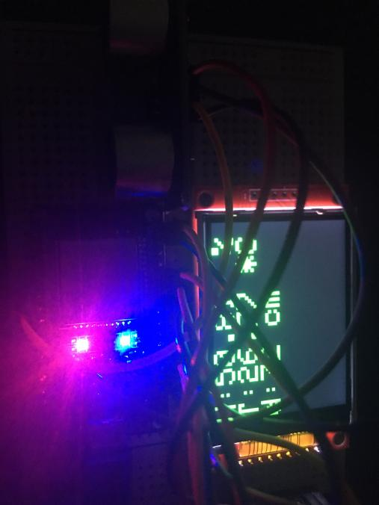

ESP32-RPI monitoring system

[**https://youtu.be/09uby85Lu7A**](https://youtu.be/09uby85Lu7A)

6088083 Nohrarit Saengsukriran Sec2

6088120 Naipawat Poolsawat Sec2

# Idea

Connect ESP32 to Raspberry Pi to use Raspberry Pi capabilities including storage (micro SD card) to store VDO footage and Pi camera.

Because the project requires ESP32, we need to use both ESP32 and RPi. However, the project can be executed with a RPi alone.

# Objective

1. Connect ESP32 to Raspberry Pi through serial connections
2. Use PiCamera

# Scenarios

When one enters the room, one will cross the ultrasonic module which is connected to ESP32. After that, the camera module which is connected to Raspberry Pi will record a video for 10 seconds.

# Finite-State-Machine diagram

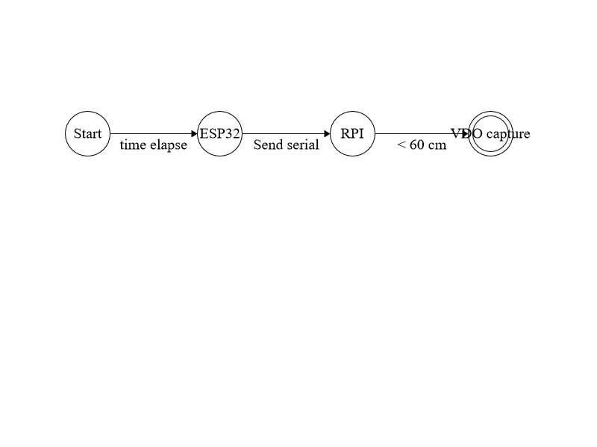

# Circuit Schematic (credit. Lab7)

